Nama : Raihan Rahmanda Junianto

NIM : 222112303

Kelas : 2KS4

**Responsi Praktikum 11 Pemrograman Berbasis Web**

1. Membuat Aplikasi AJAX Sederhana

* File telltime.php

* File showtime.php

1. Membuat Aplikasi AJAX untuk Pencarian

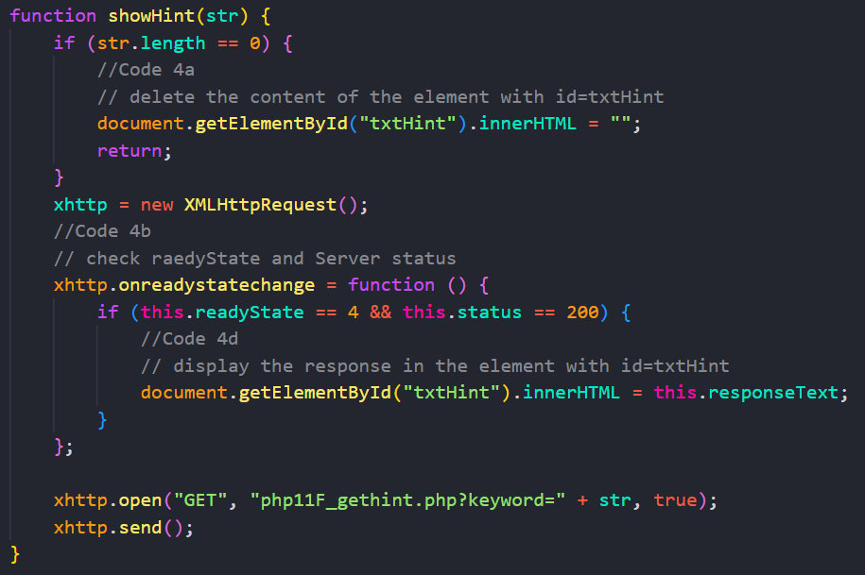

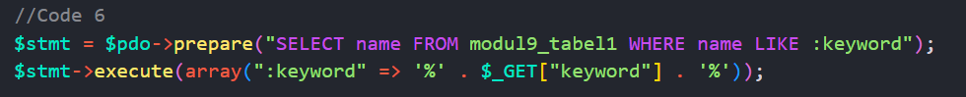

1. Menggunakan JSON pada Aplikasi AJAX untuk Pencarian

* File php11F_suggestion2.js

* File php11F_gethint2.php

